Home Learning- Jack & the Beanstalk
All the tasks for this fortnight are linked to Jack & the Beanstalk. Please find a copy attached at the bottom of the blog post.
Creative Tasks:
Make some salt dough magic beans. You could create different sized beans, different shape magic beans. Once they have dried out you could paint them.
Here is a simple salt dough recipe:
- 1 cup (250 ml) plain flour
- 1 cup (250 ml) table salt
- 1 cup (250 ml) warm water
- a small drop of cooking oil
Method:
- Mix flour and salt in a bowl.
- Make a hole in the centre and pour in water little by little
- Mix the flour, salt and water, add water as necessary until it's not crumbly.
- Knead the dough about 5 minutes until its smooth.
- Add the cooking oil to make the dough soft, pliable and smoother.
Junk Modelling Beanstalk:
Have a look in the recycling and find some materials to make a beanstalk- empty kitchen/toilet roll tubes would be particularly useful.
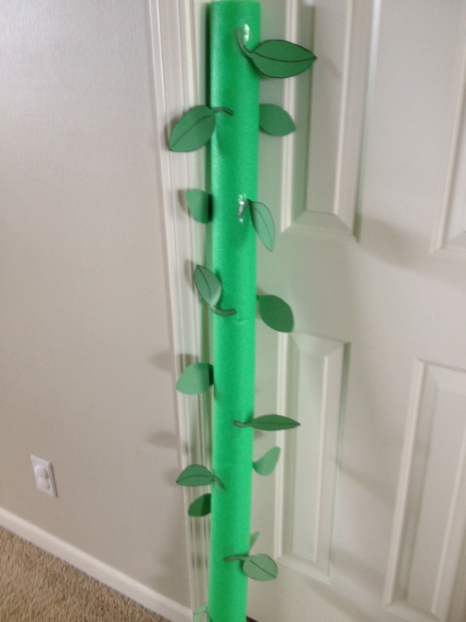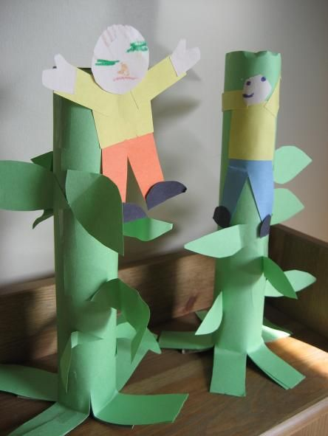
Music
Here are some links to videos of a Harp being played. They are tunes the children should hopefully recognise. Watch the man playing the harp, discuss how he’s playing the strings with his fingers etc. and have a little sing along too!
https://www.youtube.com/watch?v=E9RggRFhBGg
https://www.youtube.com/watch?v=hnQTIuuBinM
https://www.youtube.com/watch?v=mrta-Kpl-yo
https://www.youtube.com/watch?v=Km0nKr4kmfY
https://www.youtube.com/watch?v=-OEwS2Gs6jw
Footstep Music: (Apologies to parents for any headaches caused by this task)
Use household items to create the sound of the giants’ footsteps. Find some pots and pans and a selection of utensils made from different materials, such as wooden/metal spoons, spatulas, whisks etc. Investigate how the different utensils make different sounds when you bang them onto the pans. Once you’ve spent some time investigating decide which utensil and pot/pan makes the best giant footstep sound.
Extension:
How can you make Jack’s footsteps? Perhaps by being gentler when you hit the pans or by finding other items around the house which would make a smaller noise such as empty Pringles cans/ plastic bowls etc.
Growing Things:
If you have any spare seeds which you could plant together and watch grow.
If not perhaps get the children to help you water the plants already in the garden.

